Erin

Assigned to: Natasha

Reporting Month: May 2025

# Results and Discussion

# Appendix A: SGS Tables & Graphs

## Raw Sewage Table

|  |  |  |  |
| --- | --- | --- | --- |
| Date | cBOD5 | TSS | TKN |
| 07-Mar-25 | 198 | 60 | 77.1 |
| 21-Mar-25 | 199 | 69 | 92.4 |
| 04-Apr-25 | 95 | 48 | 77.5 |
| 17-Apr-25 | 186 | 65 | 73.2 |
| 02-May-25 | 279 | 65 | 92.2 |
| 16-May-25 | 613 | 45 | 97.6 |
| 30-May-25 | 242 | 56 | 92.8 |

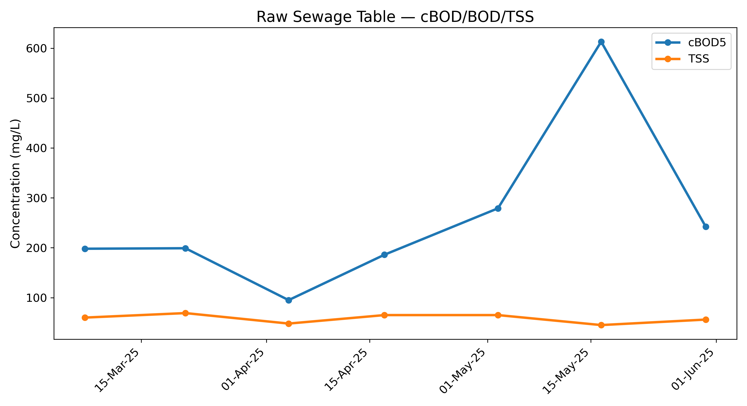

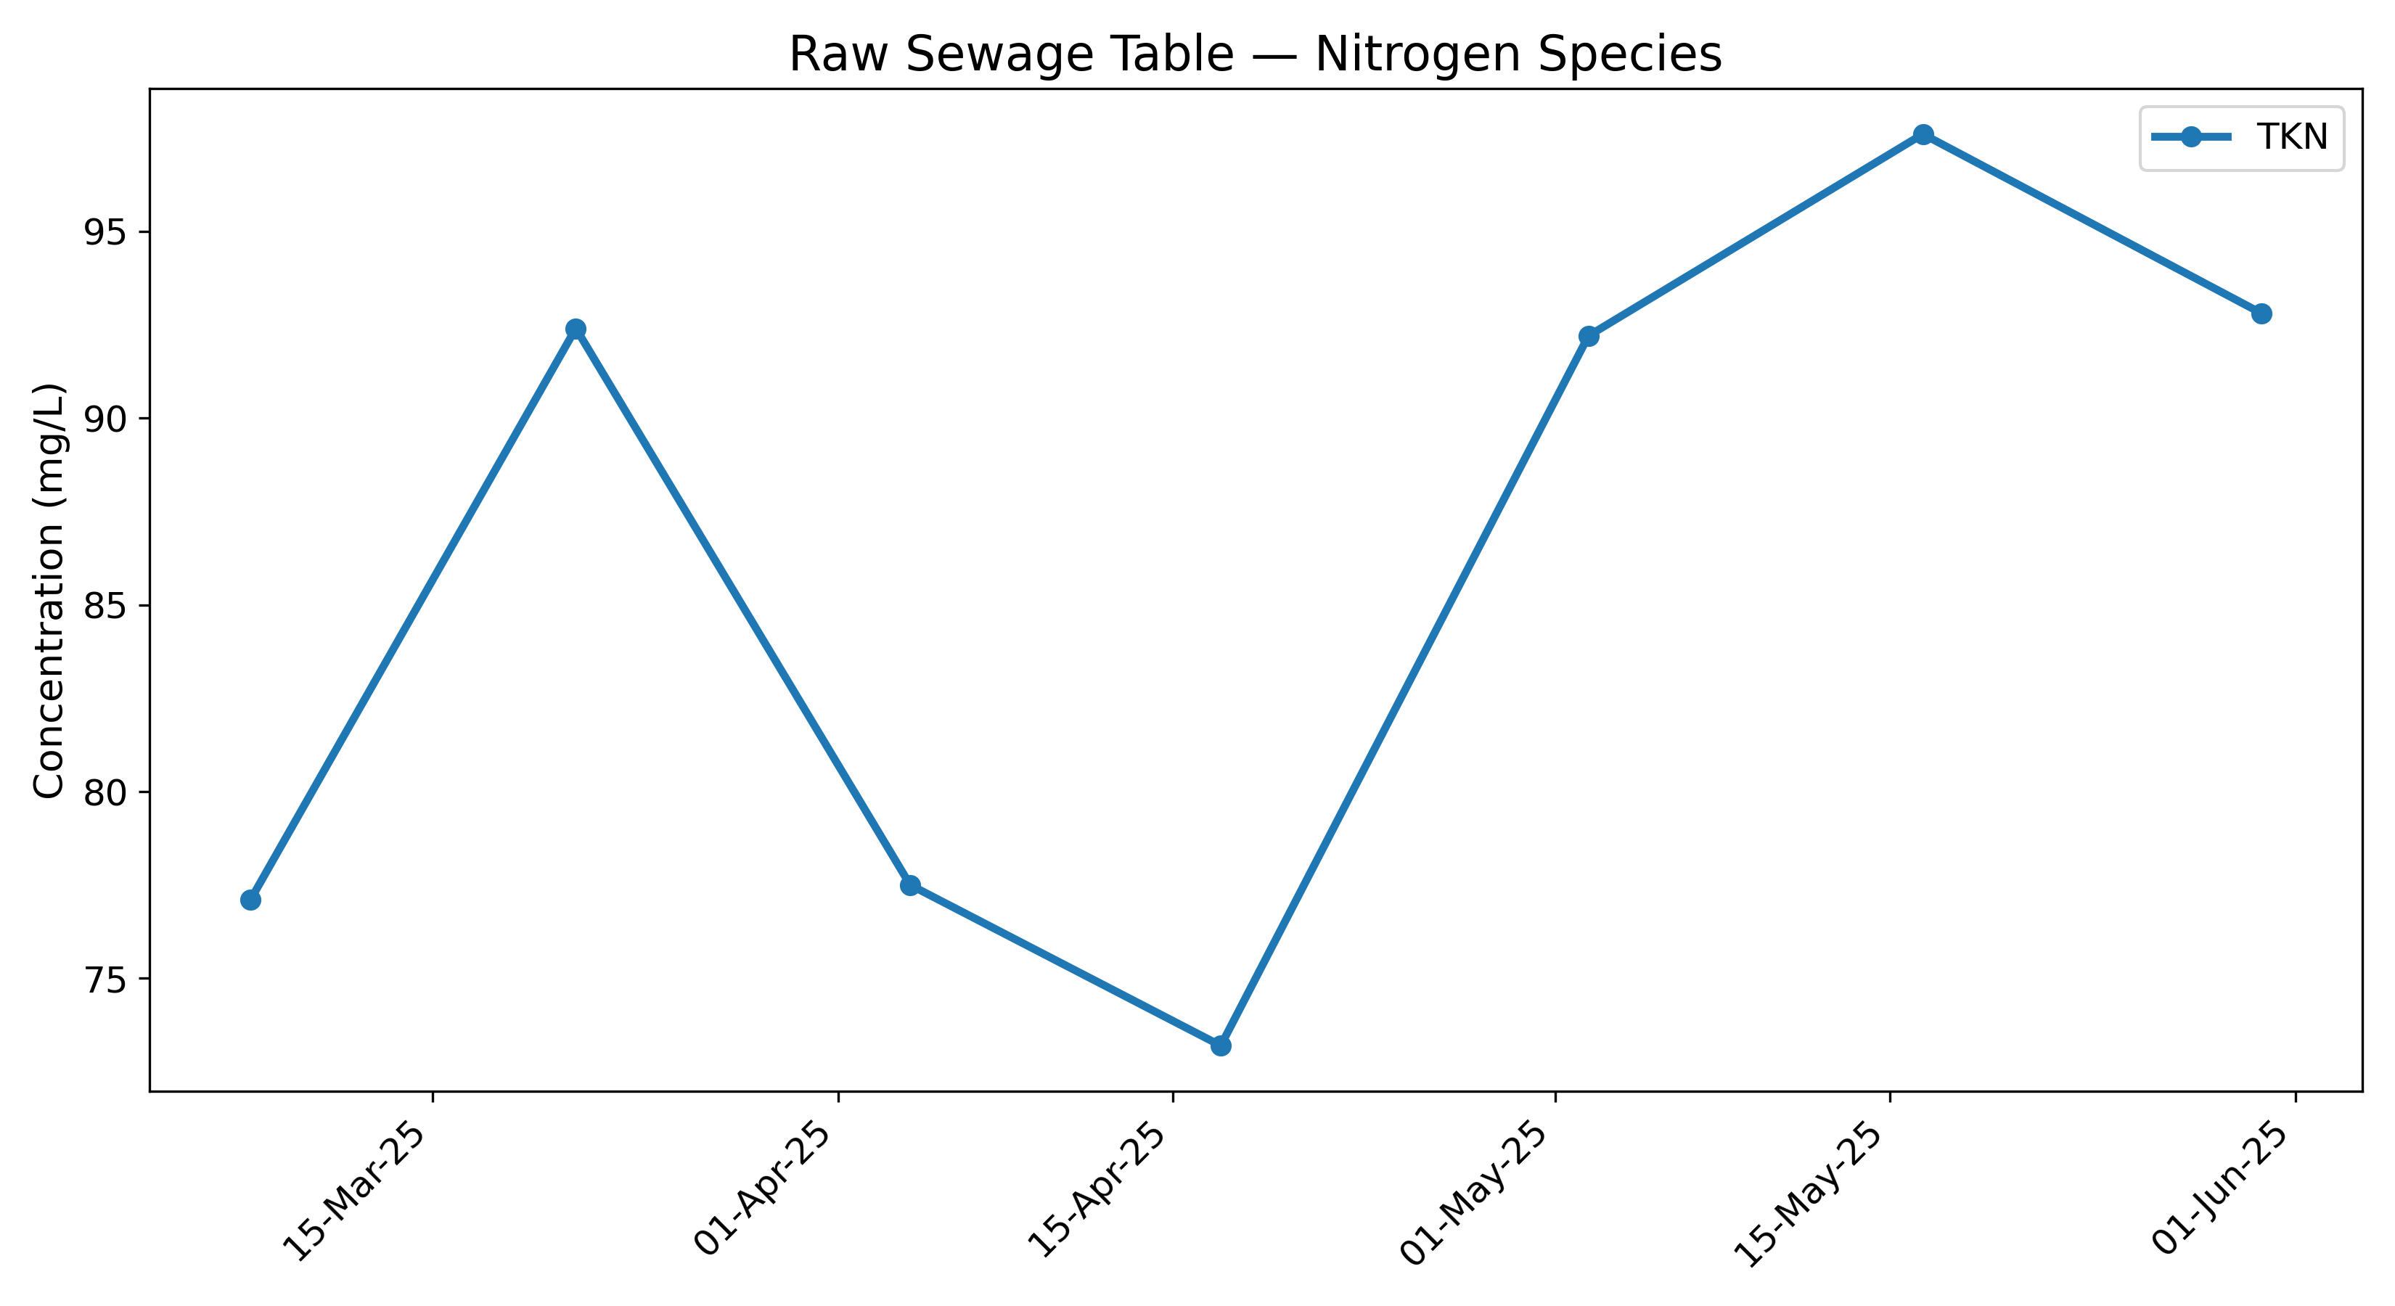

## Biofilter Effluent Table

|  |  |  |  |  |  |  |  |
| --- | --- | --- | --- | --- | --- | --- | --- |
| Date | cBOD5 | TSS | TKN | TAN | NO3 | NO2 | TN |
| 07-Mar-25 | 4 | 2 | 1.3 | 0.5 | 36.7 | 0.06 | 38.06 |
| 04-Apr-25 | 4 | 2 | 0.5 | 0.8 | 45.2 | 0.07 | 45.77 |
| 02-May-25 | 7 | 3 | 0.5 | 0.1 | 36.5 | 0.03 | 37.03 |

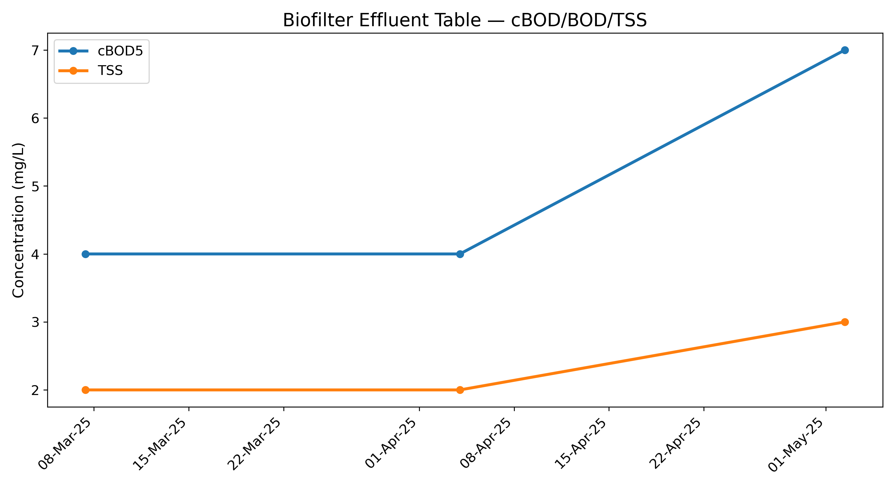

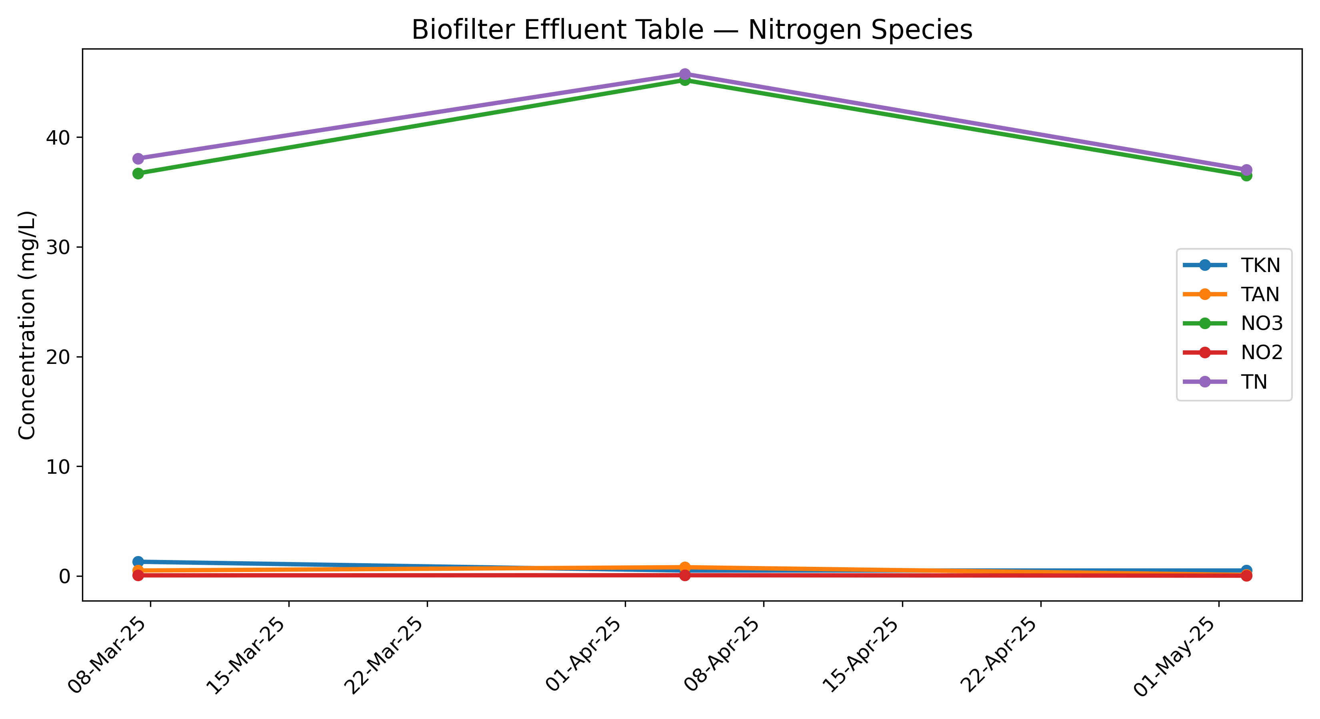

## WaterNOx Effluent Table

|  |  |  |  |  |  |  |  |
| --- | --- | --- | --- | --- | --- | --- | --- |
| Date | cBOD5 | TSS | TKN | TAN | NO3 | NO2 | TN |
| 07-Mar-25 | 4 | 6 | 3.9 | 3.6 | 21.9 | 0.41 | 26.21 |
| 04-Apr-25 | 10 | 433 | 2.7 | 2.1 | 8.89 | 5.26 | 16.85 |
| 02-May-25 | 72 | 19 | 1.8 | 1 | 0.06 | 0.3 | 2.16 |

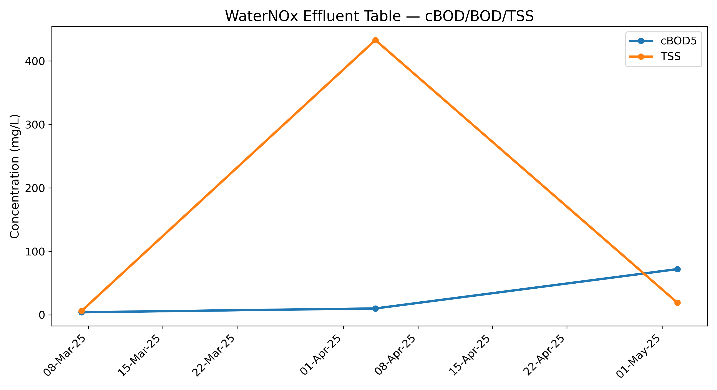

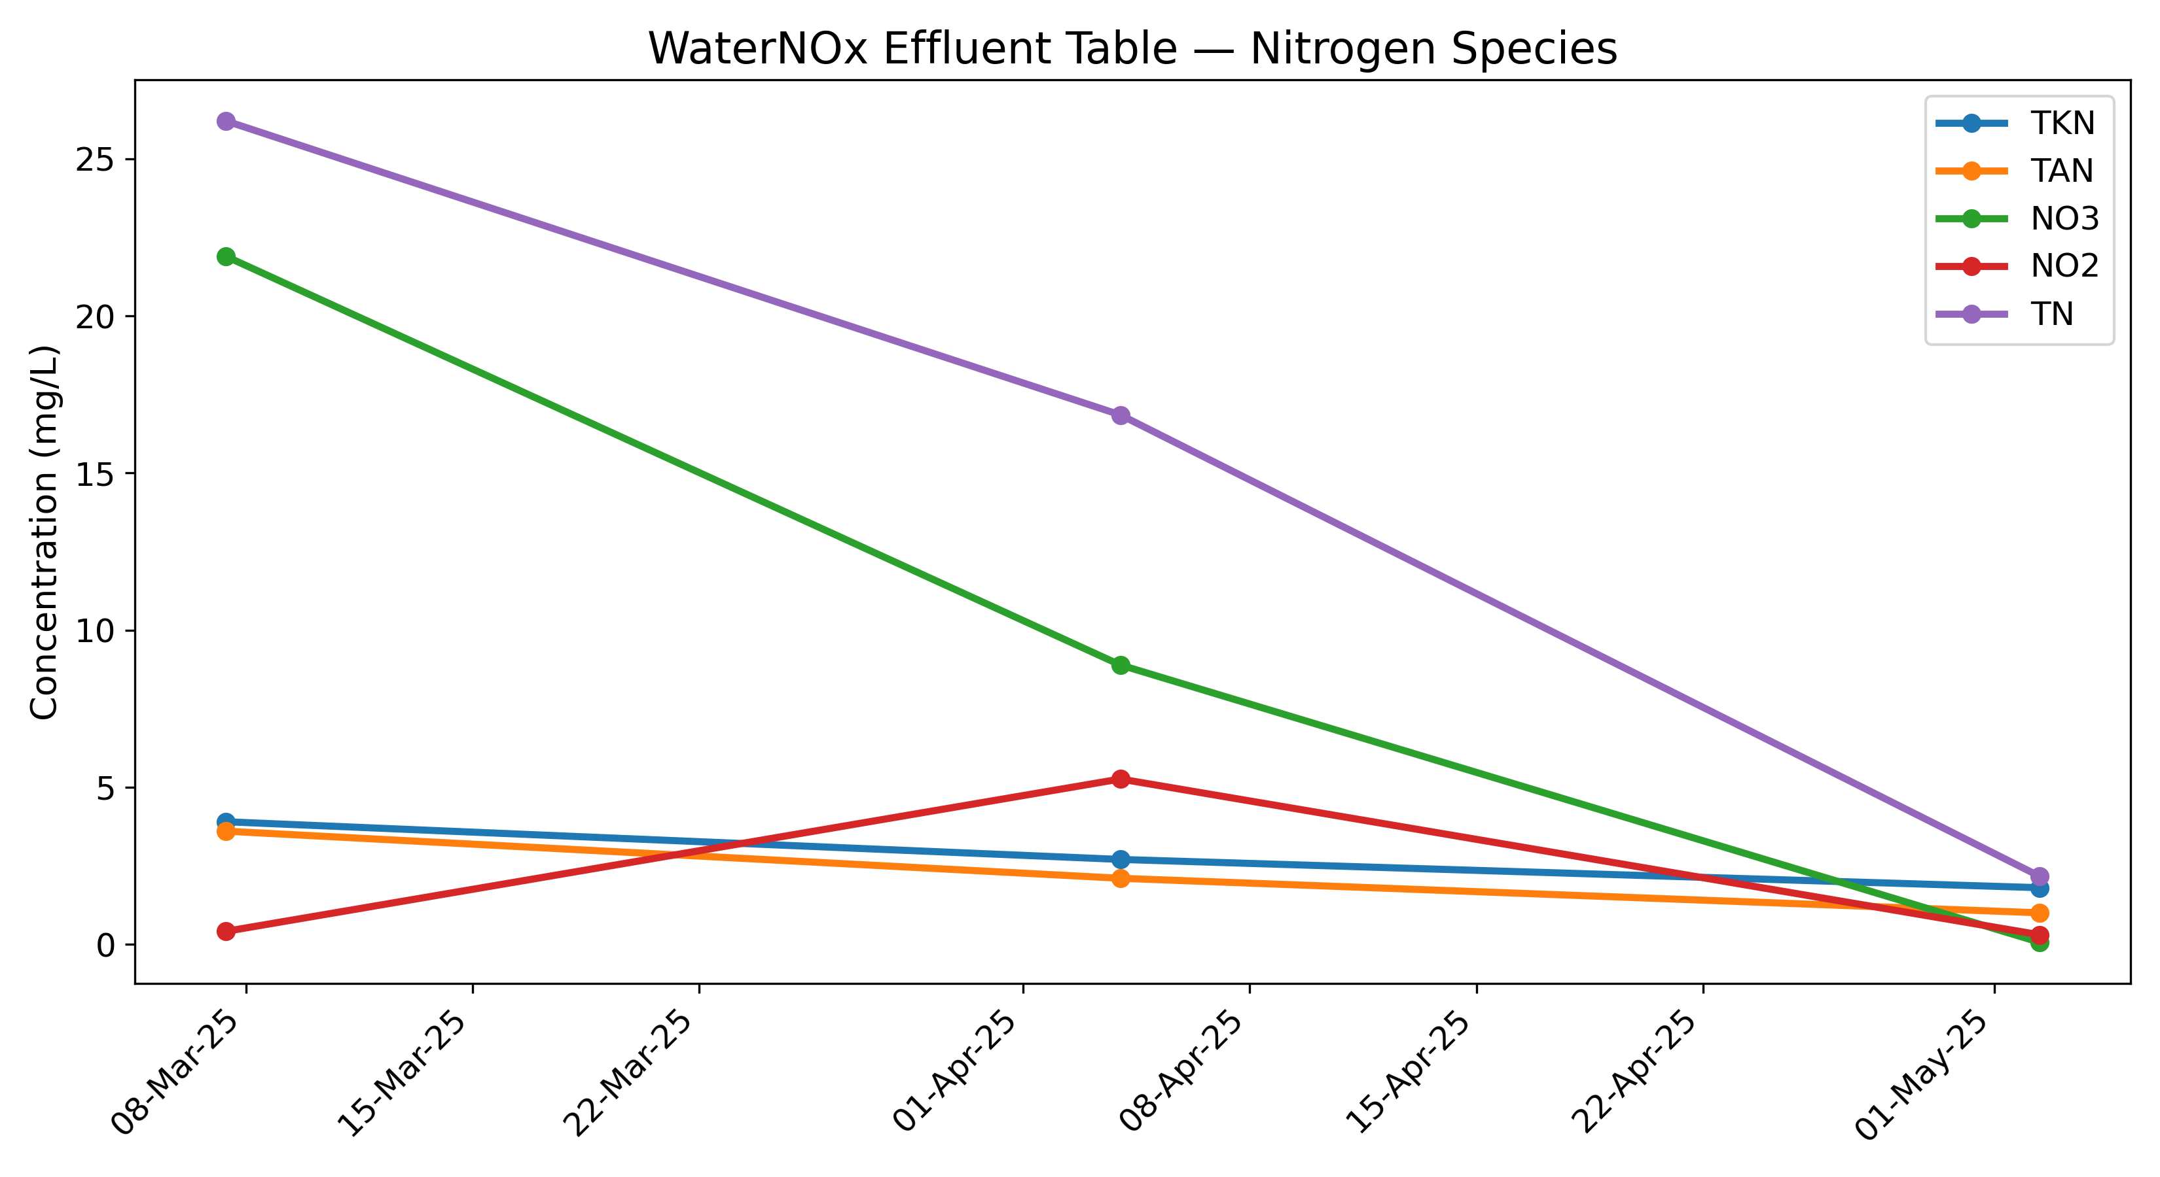

## Polisher Effluent Table

|  |  |  |  |  |  |  |  |
| --- | --- | --- | --- | --- | --- | --- | --- |
| Date | cBOD5 | TSS | TKN | TAN | NO3 | NO2 | TN |
| 07-Mar-25 | 4 | 4 | 0.9 | 0.7 | 26.1 | 0.13 | 27.13 |
| 21-Mar-25 | 4 | 2 | 1.9 | 0.5 | 26.5 | 0.04 | 28.44 |
| 04-Apr-25 | 4 | 4 | 1.4 | 0.1 | 19.7 | 0.79 | 21.89 |
| 17-Apr-25 | 4 | 10 | 0.6 | 0.1 | 2.49 | 0.15 | 3.24 |
| 02-May-25 | 4 | 6 | 0.9 | 0.1 | 0.06 | 0.3 | 1.26 |
| 16-May-25 | 4 | 3 | 0.6 | 0.2 | 1.84 | 0.3 | 2.74 |
| 30-May-25 | 4 | 4 | 0.5 | 0.2 | 1.92 | 0.03 | 2.45 |

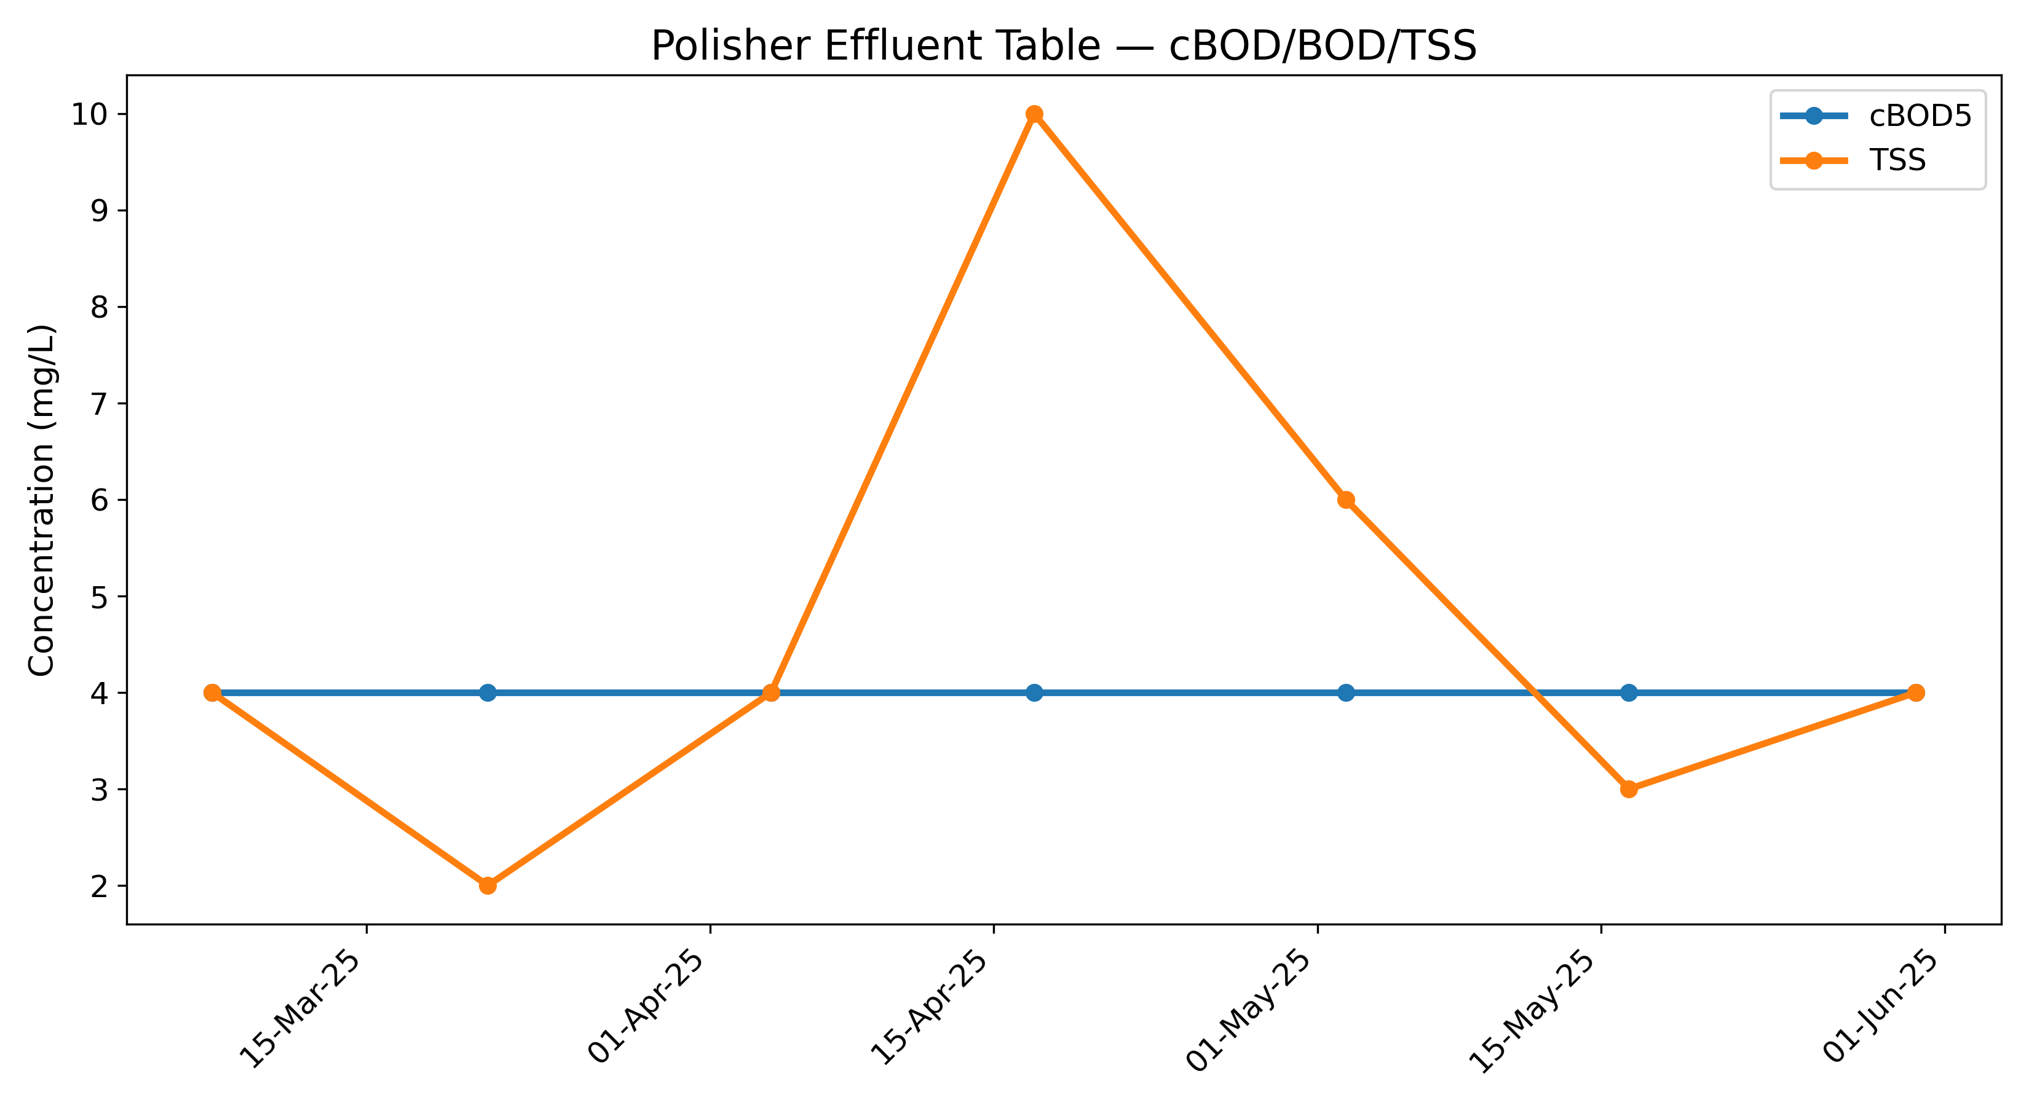

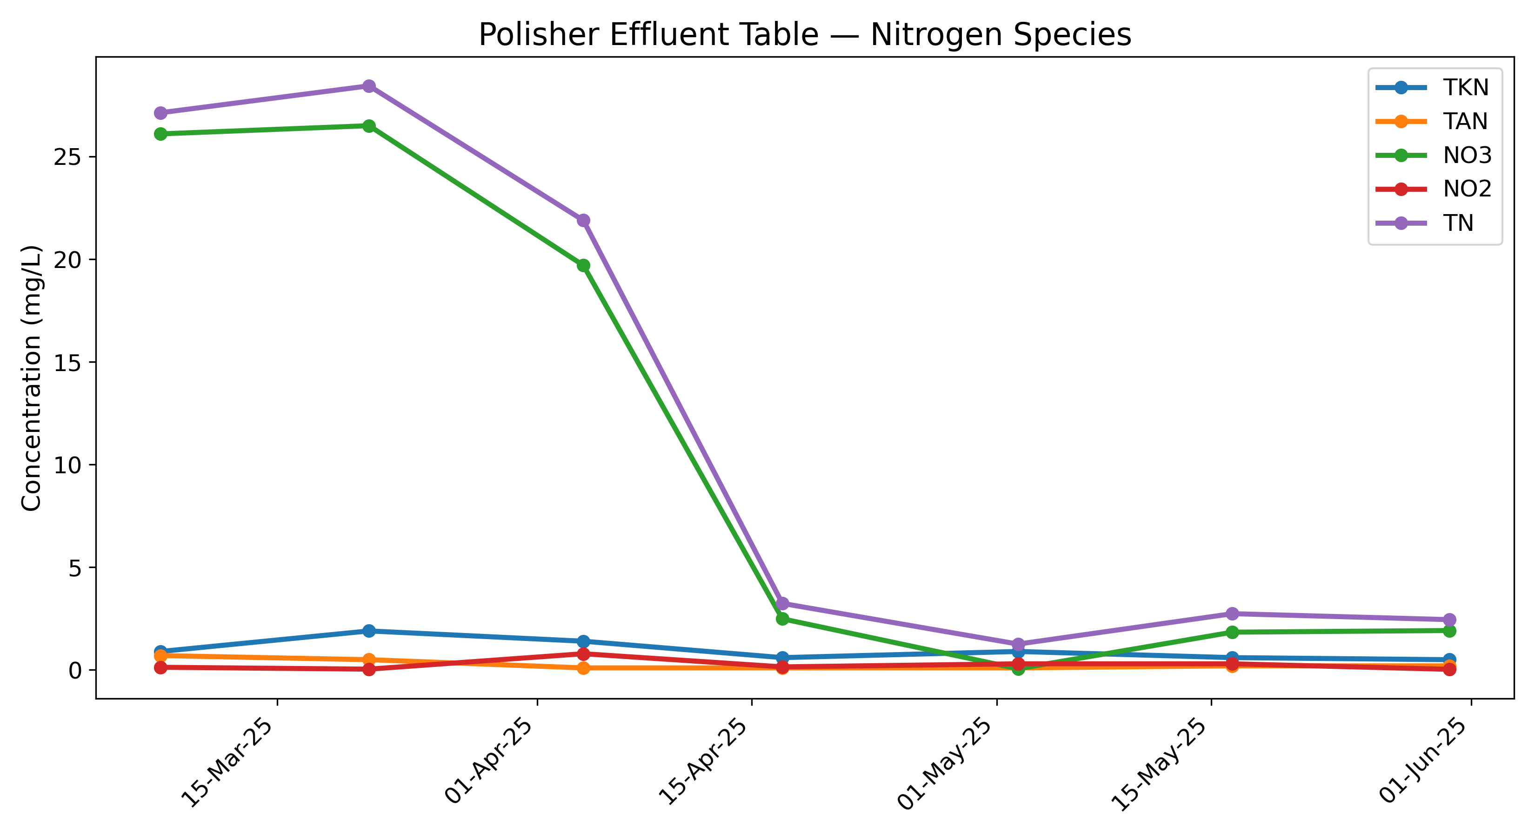

# Appendix B: Flow Data — March 2025

## Mar 25

|  |  |  |  |  |
| --- | --- | --- | --- | --- |
| Date | Flowmeter 1 Total (L) | Flowmeter 1 (L/day) | Total Daily Flow (L/day) |  |
| 01-Mar-25 | - |  | 2944 | *Smart Panel |
| 02-Mar-25 | - |  | 1920 |  |
| 03-Mar-25 | - |  | 6084 |  |
| 04-Mar-25 | - |  | 7186 |  |
| 05-Mar-25 | - |  | 12516 |  |
| 06-Mar-25 | - |  | 1970 |  |
| 07-Mar-25 | - |  | 6685 |  |
| 08-Mar-25 | - |  | 0 |  |
| 09-Mar-25 | - |  | 2434 |  |
| 10-Mar-25 | - |  | 6603 |  |
| 11-Mar-25 | - |  | 5812 |  |
| 12-Mar-25 | - |  | 6320 |  |
| 13-Mar-25 | - |  | 3271 |  |
| 14-Mar-25 | - |  | 5693 |  |
| 15-Mar-25 | - |  | 5080 |  |
| 16-Mar-25 | - |  | 4978 |  |
| 17-Mar-25 | - |  | 9219 |  |
| 18-Mar-25 | - |  | 9117 |  |
| 19-Mar-25 | - |  | 13023 |  |
| 20-Mar-25 | - |  | 9191 |  |
| 21-Mar-25 | - |  | 5959 |  |
| 22-Mar-25 | 4332100 | 9009 | 9009 |  |
| 23-Mar-25 | 4334809 | 2709 | 2709 |  |
| 24-Mar-25 | 4349935 | 15126 | 15126 |  |
| 25-Mar-25 | 4361467 | 11532 | 11532 |  |
| 26-Mar-25 | 4374949 | 13482 | 13482 |  |
| 27-Mar-25 | 4390525 | 15576 | 15576 |  |
| 28-Mar-25 | 4390525 | 0 | 0 |  |
| Total Flow (L) |  |  | 193439 |  |
| Average Flow (L/day) |  |  | 6909 |  |

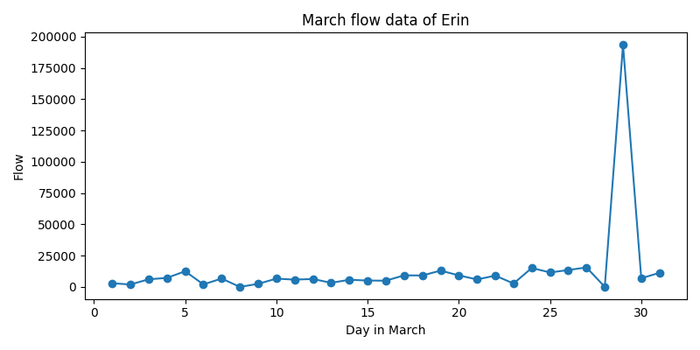

# Appendix C: Site Notes

# Appendix B: Flow Data — April 2025

## Apr 25

|  |  |  |  |
| --- | --- | --- | --- |
| Date | Flowmeter 1 Total (L) | Flowmeter 1 (L/day) | Total Daily Flow (L/day) |
| 01-Apr-25 | - | - | - |
| 02-Apr-25 | - |  | - |
| 03-Apr-25 | - |  | - |
| 04-Apr-25 | - |  | - |
| 05-Apr-25 | - |  | - |
| 06-Apr-25 | - |  | - |
| 07-Apr-25 | - |  | - |
| 08-Apr-25 | - |  | - |
| 09-Apr-25 | - |  | - |
| 10-Apr-25 | - |  | - |
| 11-Apr-25 | - |  | - |
| 12-Apr-25 | - |  | - |
| 13-Apr-25 | - |  | - |
| 14-Apr-25 | - |  | - |
| 15-Apr-25 | - |  | - |
| 16-Apr-25 | - | - | - |
| 17-Apr-25 | 4631975 | - | 12072 |
| 18-Apr-25 | 4636032 | 4057 | 4057 |
| 19-Apr-25 | 4639867 | 3835 | 3835 |
| 20-Apr-25 | 4639867 | 0 | 0 |
| 21-Apr-25 | 4646027 | 6160 | 6160 |
| 22-Apr-25 | 4656349 | 10322 | 10322 |
| 23-Apr-25 | 4668687 | 12338 | 12338 |
| 24-Apr-25 | 4682621 | 13934 | 13934 |
| 25-Apr-25 | 4690866 | 8245 | 8245 |
| 26-Apr-25 | 4696939 | 6073 | 6073 |
| 27-Apr-25 | 4698830 | 1891 | 1891 |
| 28-Apr-25 | 4706798 | 7968 | 7968 |
| 29-Apr-25 | 4718757 | 11959 | 11959 |
| 30-Apr-25 | 4730615 | 11858 | 11858 |
| Total Flow (L) |  |  | 110712 |
| Average Flow (L/day) |  |  | 7908 |

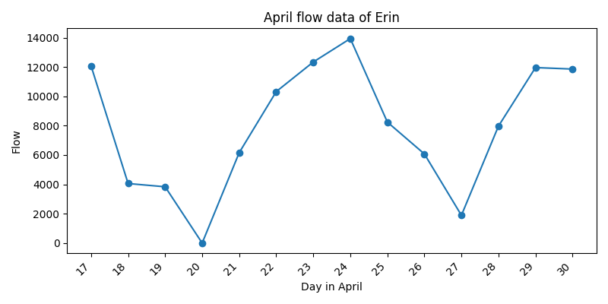

# Appendix C: Site Notes

# Appendix B: Flow Data — May 2025

## May 25

|  |  |  |  |
| --- | --- | --- | --- |
| Date | Flowmeter 1 Total (L) | Flowmeter 1 (L/day) | Total Daily Flow (L/day) |
| 01-May-25 | 4740543 | 9928 | 9928 |
| 02-May-25 | 4759366 | 18823 | 18823 |
| 03-May-25 | 4760854 | 1488 | 1488 |
| 04-May-25 | 4761862 | 1008 | 1008 |
| 05-May-25 | 4767286 | 5424 | 5424 |
| 06-May-25 | 4774780 | 7494 | 7494 |
| 07-May-25 | 4780171 | 5391 | 5391 |
| 08-May-25 | 4783345 | 3174 | 3174 |
| 09-May-25 | 4786100 | 2755 | 2755 |
| 10-May-25 | 4786435 | 335 | 335 |
| 11-May-25 | 4786847 | 412 | 412 |
| 12-May-25 | 4790575 | 3728 | 3728 |
| 13-May-25 | 4794933 | 4358 | 4358 |
| 14-May-25 | 4797294 | 2361 | 2361 |
| 15-May-25 | 4797986 | 692 | 692 |
| 16-May-25 | 4798618 | 632 | 632 |
| 17-May-25 | 4798670 | 52 | 52 |
| 18-May-25 | 4798721 | 51 | 51 |
| 19-May-25 | 4798774 | 53 | 53 |
| 20-May-25 | 4807896 | 9122 | 9122 |
| 21-May-25 | 4826522 | 18626 | 18626 |
| 22-May-25 | 4840271 | 13749 | 13749 |
| 23-May-25 | 4849300 | 9029 | 9029 |
| 24-May-25 | 4853753 | 4453 | 4453 |
| 25-May-25 | 4856044 | 2291 | 2291 |
| 26-May-25 | 4865246 | 9202 | 9202 |
| 27-May-25 | 4878625 | 13379 | 13379 |
| 28-May-25 | 4891838 | 13213 | 13213 |
| 29-May-25 | 4902952 | 11114 | 11114 |
| 30-May-25 | 4907115 | 4163 | 4163 |
| 31-May-25 | 4920324 | 8694 | 8694 |
| Total Flow (L) |  |  | 185194 |
| Average Flow (L/day) |  |  | 5974 |

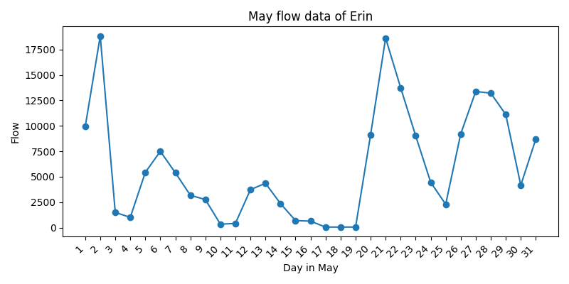

# Appendix C: Site Notes